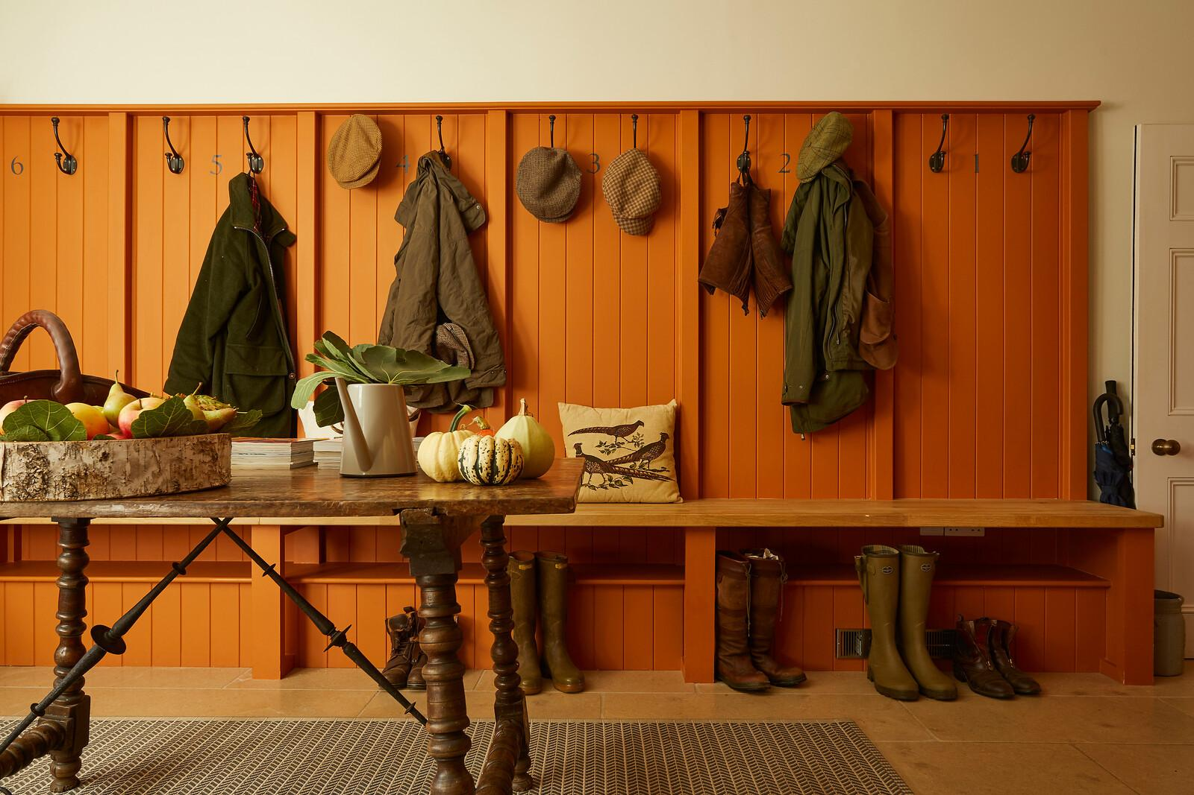

Accessibility Guide for Manor Farmhouse
manorfarmhouse@overburyenterprises.co.uk
01386 725111
www.manor-farmhouse.co.uk
Contact for accessibility enquiries: Penelope Bossom

Welcome
A luxury Cotswold farmhouse on a private country estate. Manor Farmhouse, Conderton has 8 bedrooms and 8 bath/shower rooms for guests to relax and enjoy luxurious quality in a homely, rural setting.
Nestled into a picturesque hamlet, with easy walking access from the pretty terraces into the Orchard behind and directly onto the beautiful slopes of Bredon Hill. Guests have everything they need to experience the Cotswolds whilst hosting the perfect get together with friends and family around the log fire.
Unfortunately, we have limited ability to add or modify the property for wheelchair and disability users as Manor Farmhouse is a converted Grade II Listed building. There are many steps inside and outside the property that restrict disability access.

At a Glance

Level Access
- The main entrance (front door) has 3 steps. There is no lift and no ramp.
- There is level access from the car park to:
  - Back Garden

Access with steps
- There are steps from the main entrance front door to:
  - Bedrooms, all upstairs
  - 2 x Sitting Rooms
  - North Passage
  - Kitchen & Dining Room
  - Front Garden
  - Back Garden Terrace

Bedrooms
- Our bedding is feather based, but some non-allergic bedding is available if requested in advance.

Disability
- Some staff have disability awareness training.

General
- We have an emergency/out of hours mobile phone number for guest use, however there is always someone on hand during business hours if required.

Getting here
Main Street
Conderton
Nr Tewkesbury
GL20 7PP
https://w3w.co/track.forgotten.surveyors

Travel by public transport
- You can get to Manor Farmhouse by bus and train.
- There is one bus stop on opposite side of the road of Manor Farmhouse in Conderton going in direction to Kemerton (on towards Tewkesbury) and other bus stop at the bottom of the drive of Manor Farmhouse going in the other direction towards Beckford (on towards Evesham). The bus stop is 0 miles / 0.0 km from Manor Farmhouse.
- The nearest train station is Ashchurch for Tewkesbury. The train station is 5 miles / 8.1 km from Manor Farmhouse. The train station in Evesham has a direct train to London via Oxford, which goes into Paddington Station.
- The station is a 15 min car journey from the house.

Travel by taxi
- You can get a taxi with Tewkesbury Hills Cars by calling 01684 592929.

Parking
- We have a large car park. The parking is less than 50 metres from the main entrance. Parking is free.
- There is a drop-off point at the main entrance. The drop-off point does not have a dropped kerb.
- From the parking to the main entrance, there are 3 steps. There is no ramp and no lift.
- The car park is covered with gravel. You can access the house via the front door but there are 3 steps at the doorstep. You can acess the house from the back door, but there are 2 steps down from the car park, then one step at the doorstep then 2 steps internally from back door to first room.
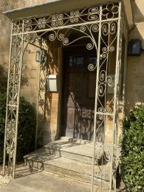
steps to front door step at back door

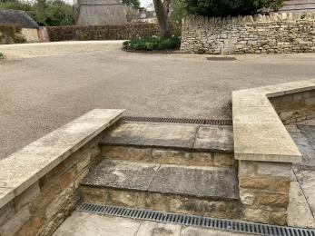
steps from car park to back door back door internal steps inside property

Arrival

Path to main entrance
- From the street to the main entrance, there are 3 steps at front door. There is no ramp and no lift.
- The path is sloped.

Main entrance
- The door is 9040mm wide.
- The main entrance front door has 3 steps.
- There are gravel paths to the front door and in the carpark.
There is access to the house from the back door, but there are 3 steps from car park to back door. Then one step at back door, then 2 internal steps from back door into Bootroom.
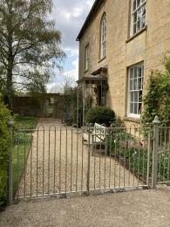
path from driveway to gain access to front door car park
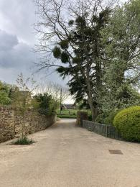
looking down driveway from side of house step to back door
car park steps to back door back door internal steps to Bootroom

Getting around inside

Bedrooms
- All bedrooms have windows.
- Bedrooms have ceiling lights, bedside lamps and natural daylight.
- Lights are halogen, LED and traditional filament. Some lights can be controlled independently.
- All bedrooms are non-smoking.
- Our bedding is feather based, but some non-allergic bedding is available if requested in advance.
- Some bedrooms have fitted carpets.
- For visitors with electro-sensitivity, Wi-fi can be switched off in bedrooms if requested in advance.
- We can move the bedroom furniture, to improve accessibility, if requested in advance (and must be returned to original position at departure).
- No bedrooms have level access. The bedroom nearest the main entrance has 14 steps.
- We have bathrooms with a separate shower.
- We have bathrooms with a bath
- Organic shampoo, conditioner, handsoap and shower gel are provided in all bathrooms.

Self catering kitchen

kitchen
- We have a separate kitchen and dining room. From the main entrance front door to the kitchen, there are 3 steps externally. There is no lift and no ramp.
- From the main entrance front door to the dining room, there are 3 steps externally. There is no lift and no ramp.
- Access from the back door to the dining room has one step to back door externally, 2 steps internally then level access to dining room.
Access from the front door to the dining room has 3 steps externally to front door then level access internally to dining room.

Lounge

Sitting Room
- From the main entrance to the lounge, there are 3 steps. There is no lift and no ramp.
- Access from the back door to the sitting room has one step to back door externally, 2 steps internally then level access to sitting room.
Access from the front door to the sitting room has 3 steps externally to front door then level access internally to sitting room.

North Passage
- From the main entrance to this area, there is 1 step. There is no lift and no ramp.
- Outside the kitchen there is an internal passageway leading to the staircase and sitting rooms at the front of the house, but there is also a second WC at the back of the house but there is a step to access the back of the house area.
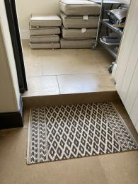
internal step in north passage

Getting around outside

Front Garden
- From the main entrance to the gardens, there are 3 steps. There is no lift and no ramp.
- Access from the car park to the front garden has level access but if you exit the front door to the front garden there are steps at front door.
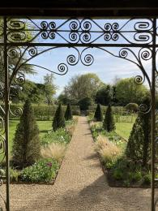
front garden from front door

Terrace

Terrace
- From front garden and front door there are 3 steps at the garden gate leading to the back garden. The Terrace is in the back garden and has 3 steps to seating area.
From inside the house there are steps down from the doors in the dining room and the North Passage out to the garden.
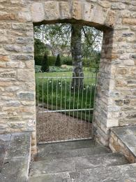
front garden gate and steps
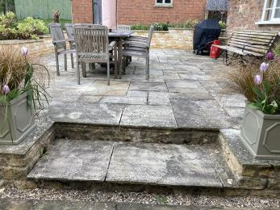
step to terrace seating area
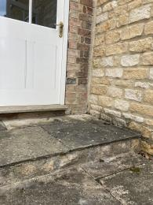
north passage doorstep to outside
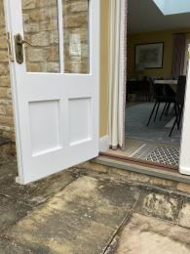
dining room step to outside

Back Garden
- There are two gates from the carpark at the back of the house leading through to the back garden. One gate measures 1100mm wide, the other measures 1850mm wide.
There are level paths within the garden but steps to the terrace from one side of the terrace.
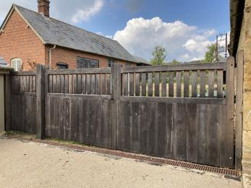
large garden gate access from car park
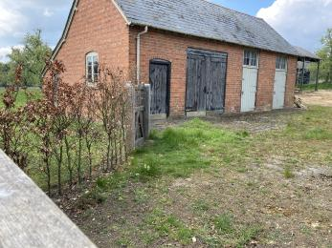
space between large gate and smaller gate to access back garden
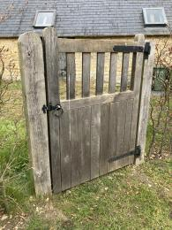
small gate access to back garden
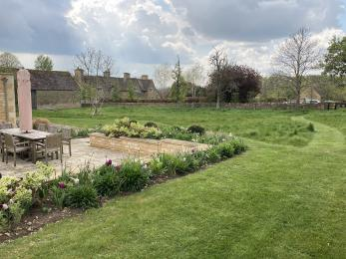
level access in back garden and to terrace
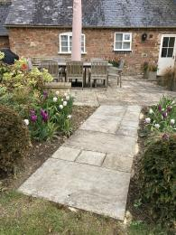
level access to terrace on one side

Customer care support

Accessibility equipment
- None is provided/available
- No hearing loop is available
- The toilet area for assistance dogs is in the back garden or nearby yard but dog waste must be picked up and put in a dog waste bin.
- Some staff have disability awareness training.
- We have an emergency/out of hours mobile phone number for guest use, however there is always someone on hand during business hours if required.
- There is a Defibrillator located nearby in Overbury at The Village Hall
https://what3words.com/call.crunches.jeeps

Guide last updated: 11 May 2021 – Visit England
Any information, comments and views made available to users via this Accessibility Guide are provided directly from third party business operators. VisitEngland and VisitScotland do not endorse or validate this information. Any reliance on this Accessibility Guide is at your own risk. This guide is not intended to be a substitute for users making their own checks, inquiries and investigations directly with the business operators prior to making any booking or visiting the venue.


